
LESSON NOTE | DETAILED EXPLANATORY NOTES
ECOLOGY & EVOLUTION
MECHANISMS OF EVOLUTION & EXTINCTION

GRADE 12 - BIOLOGY
■ ■ ■

How Populations Evolve - and Disappear
Evolution is a change in the inherited features of a population over generations. Natural selection is the best-known cause, but it is not the only one: mutation, gene flow and genetic drift also change populations. Sometimes these processes lead to the formation of a new species (speciation); at other times a species cannot cope with change and dies out completely - extinction. Together, these mechanisms explain both the origin and the loss of the huge variety of life on Earth.
This lesson describes the four mechanisms of evolution, how new species form, and the causes and importance of extinction. It brings together the earlier lessons on natural selection and evidence for evolution, and is a key topic in the Ecology & Evolution strand.
Why This Matters
- Several mechanisms - not just selection - drive evolution.
- Speciation explains how new species arise.
- Extinction is a natural, but now accelerating, part of life's history.
- These ideas guide conservation and biodiversity protection.
Mechanisms of Evolution & Extinction
Key Learning Outcomes
By the end of this lesson, students should be able to:
- Name and explain the four mechanisms of evolution.
- Explain how mutation provides variation and gene flow spreads it.
- Explain genetic drift and how chance affects small populations.
- Describe how speciation produces new species.
- Explain the causes and importance of extinction.
The Mechanisms of Evolution
Evolution - a change in the allele frequencies of a population - is driven by four main mechanisms. Natural selection favors the alleles that help organisms survive and reproduce. Mutation is the ultimate source of new alleles - it creates the variation on which the other processes act. Gene flow is the movement of alleles between populations when individuals (or pollen, or seeds) migrate, mixing their genes. Genetic drift is a change in allele frequencies due to random chance - important in small populations, where a chance event can wipe out or spread an allele regardless of whether it is helpful. Together, these mechanisms change populations over time.
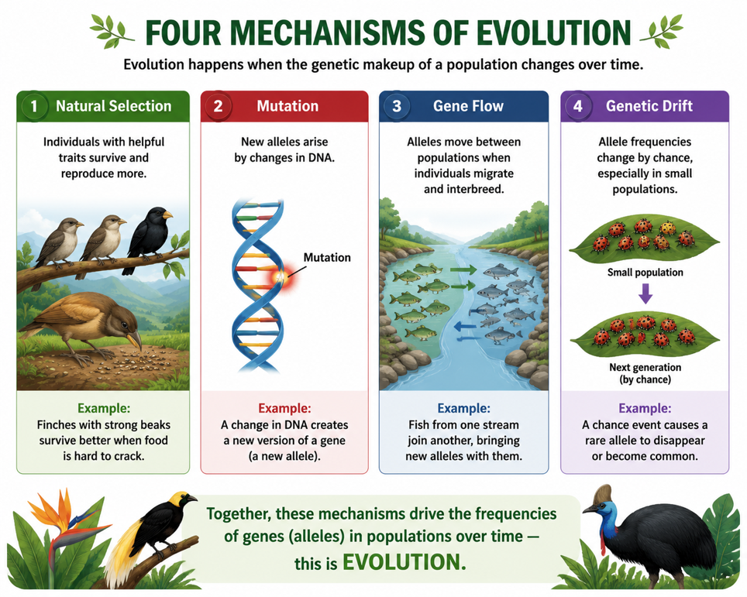
Figure 1: The four mechanisms of evolution - natural selection, mutation, gene flow and genetic drift.
Terminologies and Concepts
Useful terms for this topic:
- Allele frequency: how common an allele is in a population.
- Mutation: a change in DNA that creates new alleles (raw material for evolution).
- Gene flow: movement of alleles between populations through migration.
- Genetic drift: random change in allele frequencies, strongest in small populations.
- Speciation: the formation of a new species.
- Isolation: a barrier that stops two populations interbreeding.
- Extinction: the permanent loss of a species.
Speciation - How New Species Form
A species is a group of organisms that can interbreed to produce fertile offspring. Speciation is the formation of a new species. It often happens when a population becomes isolated - split by a barrier such as a mountain range, river, sea or island. The separated groups can no longer interbreed, so they evolve independently: mutation, selection and drift act on each group differently, because their environments and chance events differ. Over many generations the two groups become so different that they can no longer interbreed even if brought back together - they have become separate species. Islands and rugged landscapes are especially good at producing new species.
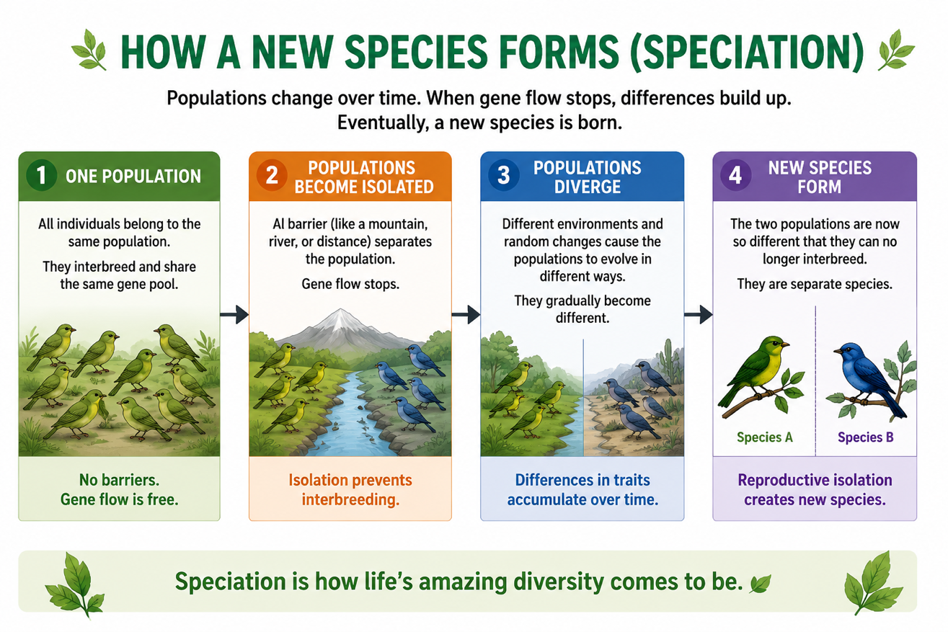
Figure 2: Speciation - an isolated population evolves separately until it becomes a new species.
Extinction
Extinction is the permanent loss of a species - it happens when the last individual of that species dies. Extinction is a natural part of life's history; over 99% of all species that have ever lived are now extinct. Causes include habitat loss, rapid climate change, overhunting or overfishing, invasive species, and sudden catastrophes such as asteroid impacts or huge volcanic eruptions. There have been at least five mass extinctions in Earth's history, including the one that wiped out the dinosaurs. Extinction becomes a problem when it happens far faster than normal - as it is today, largely because of human activity.
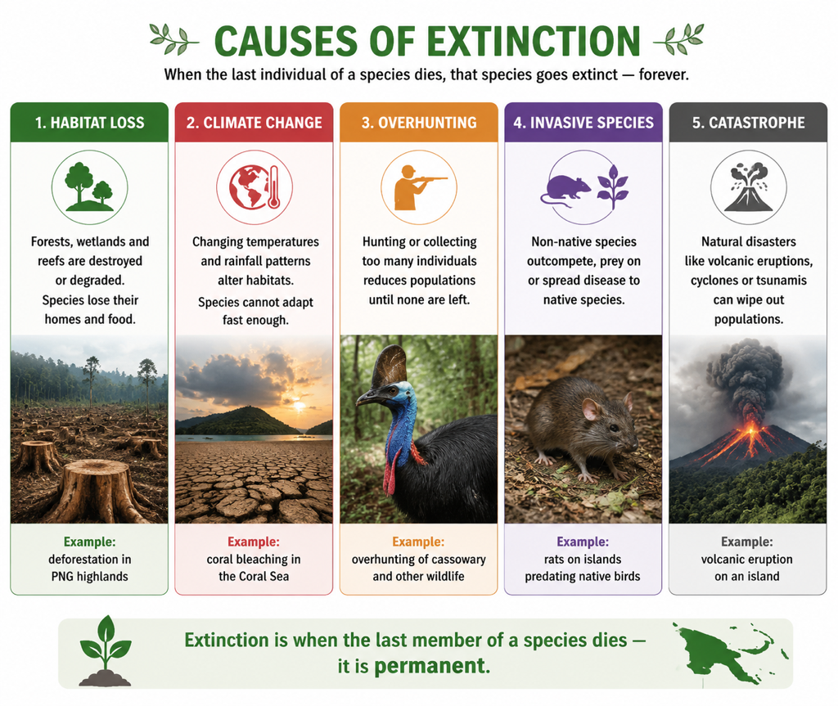
Figure 3: The main causes of extinction - the permanent loss of a species.
Evolution and Extinction Together
Evolution and extinction are two sides of the same story. As some species evolve and split into new ones, others fail to adapt to a changing environment and die out. Mass extinctions, though devastating, have also opened up opportunities - the extinction of the dinosaurs, for example, allowed mammals to expand and diversify. So over Earth's long history, the total variety of life is shaped by the balance between the origin of new species and the loss of others. Today, protecting biodiversity means slowing the human-caused extinctions happening around the world.
Why This Matters
- Biodiversity - evolution and extinction together shape the variety of life.
- Conservation - understanding extinction helps us prevent it.
- Small populations - genetic drift warns why tiny populations are vulnerable.
- The future - human activity is now a major driver of extinction.
PNG Context Example
Papua New Guinea shows both sides of this topic vividly. Its many islands and isolated valleys have driven remarkable speciation - producing thousands of unique species (endemics) found nowhere else, from birds of paradise to countless insects and frogs. But this makes them especially vulnerable to extinction: because many species live in only one small area, habitat loss from logging and mining, invasive species, overhunting and climate change could wipe them out permanently. Small, isolated populations are also at risk from genetic drift. Understanding these mechanisms is vital for conservation and protecting PNG's globally important biodiversity.
References & Related Documents
Source Documents
- Biology Standards-Based Syllabus, Grades 11 & 12 (PNG SBC 2020) - Strand: Ecology & Evolution; explain the mechanisms of evolution, speciation and the causes of extinction.
- STEM Biology Syllabus - Grade 12. Thema: Evolution; Module: Mechanisms of Evolution and Extinction. Department of Education, PNG.
Further Reading & References
- OpenStax Biology - Population Genetics; Formation of New Species; Extinction. https://openstax.org/books/biology
- Khan Academy - Mechanisms of evolution; speciation and extinction. https://www.khanacademy.org/science/biology/her

